13th September 2025
Parents’ Evening October 2025

Dear Parents/Carers

Please see dates below for parents’ consultations this term:

Tuesday 7th October 2025: Nursery, Reception, Year 1, Year 2 and Resource Base.

Thursday 9th October 2025: Year 3, 4, 5 and 6.

You will be able to make a 5-minute appointment with your child’s teacher on the Arbor App. You will be able to use the App to book a time from 8.00 on 22nd September 2025 until 12.00 on 3rd October 2025

All meetings will take place in the school halls with appointments available from 3.45 – 5.55pm. Access to the meetings will be via the red door.

Please be advised that there is limited seating and waiting space. Where possible, can we ask that only parents and the child attend. We look forward to seeing you there.

If for any reason, you cannot attend on the given date or you are unable to book on the Arbor, please see the class teacher.

Kind regards,

A.Hazeldine
Associate Head of School

How to book an appointment on Arbor:

- Access Guardian Consultations:
On the main page, select Guardian Consultations.
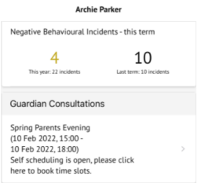
Alternatively, click the menu icon at the bottom left, then select Guardian Consultations.

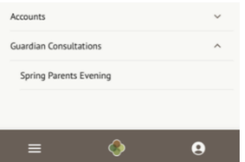
- Book a Meeting:
Click the available meeting.
Use the Time slot drop-down to choose your preferred time.
Select which guardians will attend by ticking the boxes next to their names.
Add any notes for discussion.
Click Book time slot.
Confirm your choice and you'll receive an email confirmation.
. 