5th November 2025

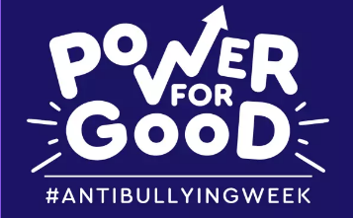

Dear Parents,

Birchfield school will be taking part in Anti-Bullying Week from 10th to 14th November 2025. This is a fantastic opportunity for all children to engage in discussions and activities promoting kindness, inclusion, and respect. Participation in the week’s events is free for all children.

The theme for this year’s Anti-Bullying Week is “Power for good”.

To kick off the week, we invite all children to wear odd socks on Monday 10th November to celebrate what makes us unique.

Throughout the week, a variety of activities will be organised for the children to take part in. Additionally, we are running an Anti-Bullying Competition, where children can design a poster about bullying

Children can enter the competition at home and hand in their entries to the class teacher. The deadline for all entries is Friday 14th November 2025, so please encourage your child to get creative!

For more information and resources about bullying, we encourage you to visit the Anti-Bullying Alliance website at www.anti-bullyingalliance.org.uk.

Yours sincerely,

Mrs A. Hazeldine
Associate Head of School

